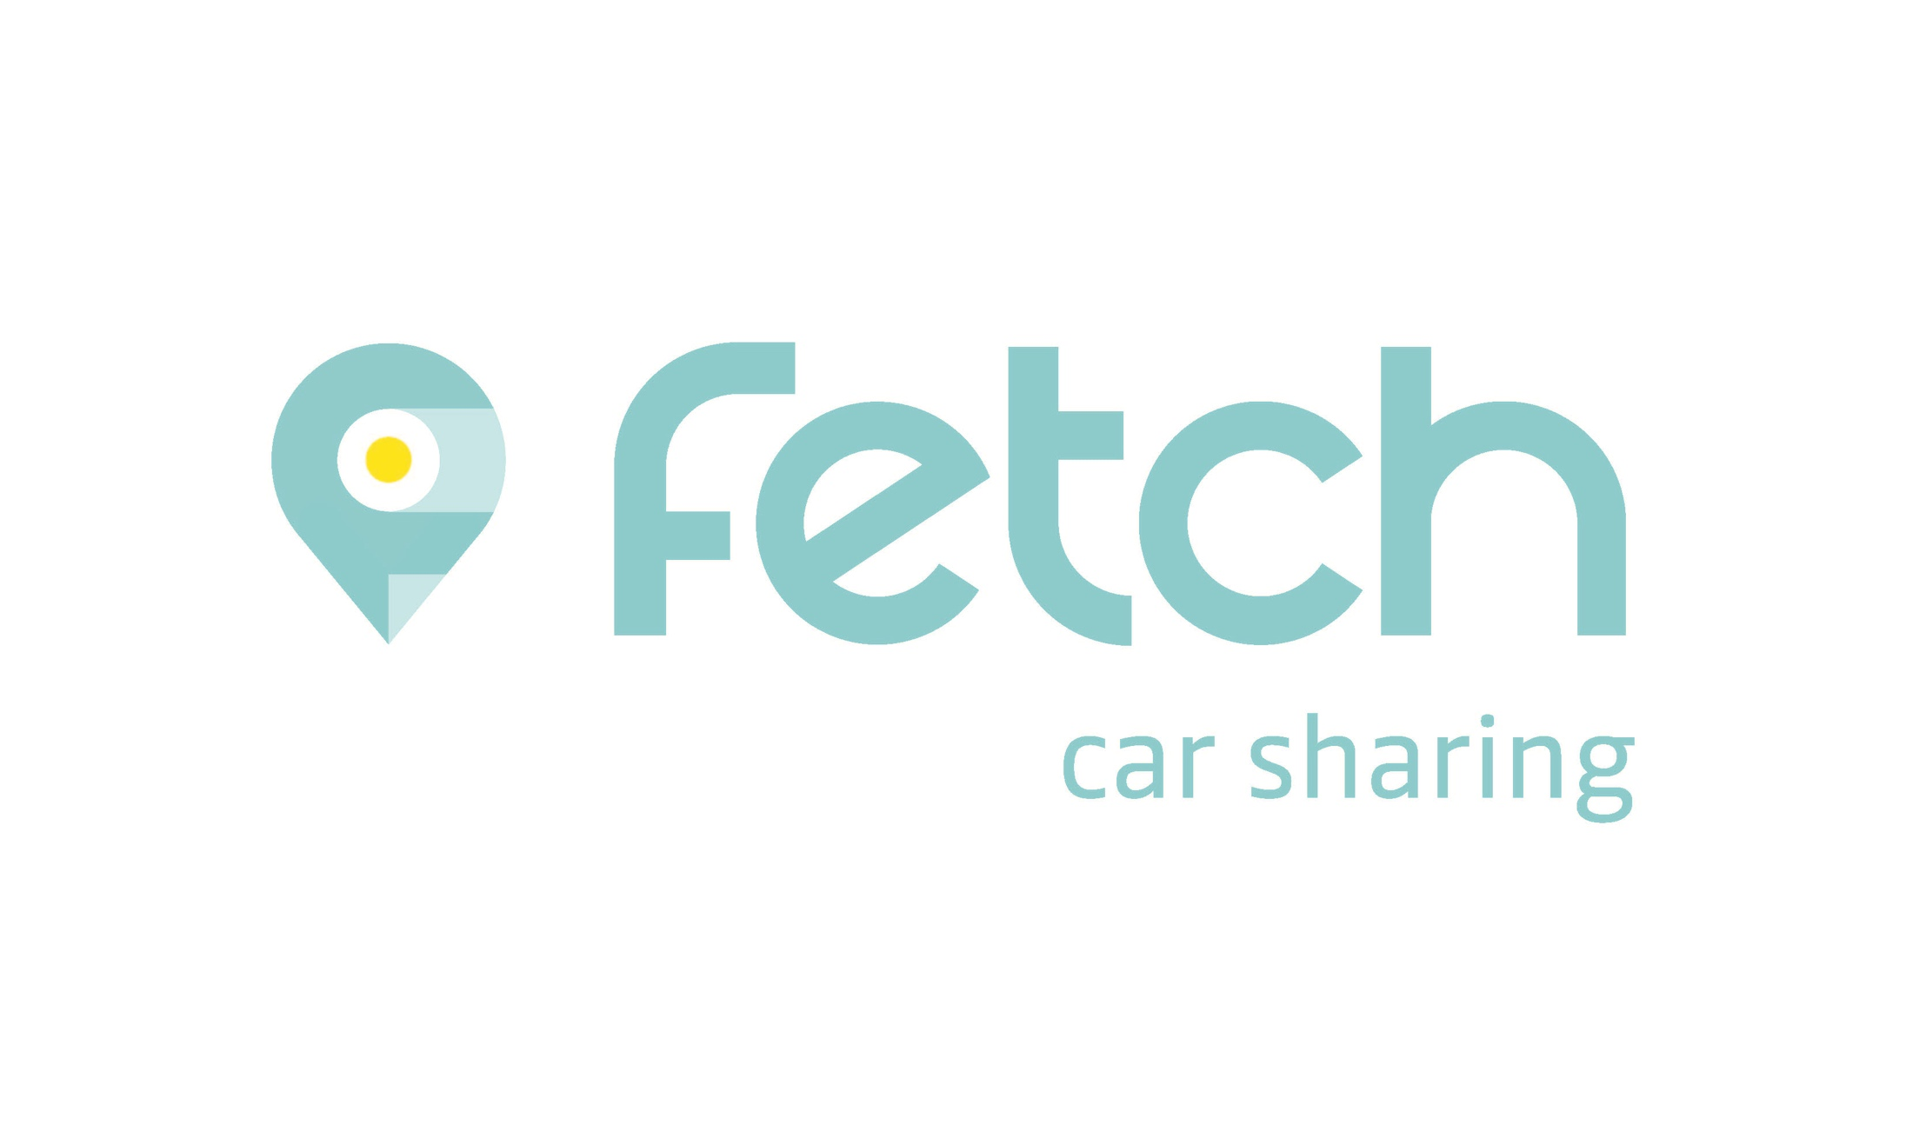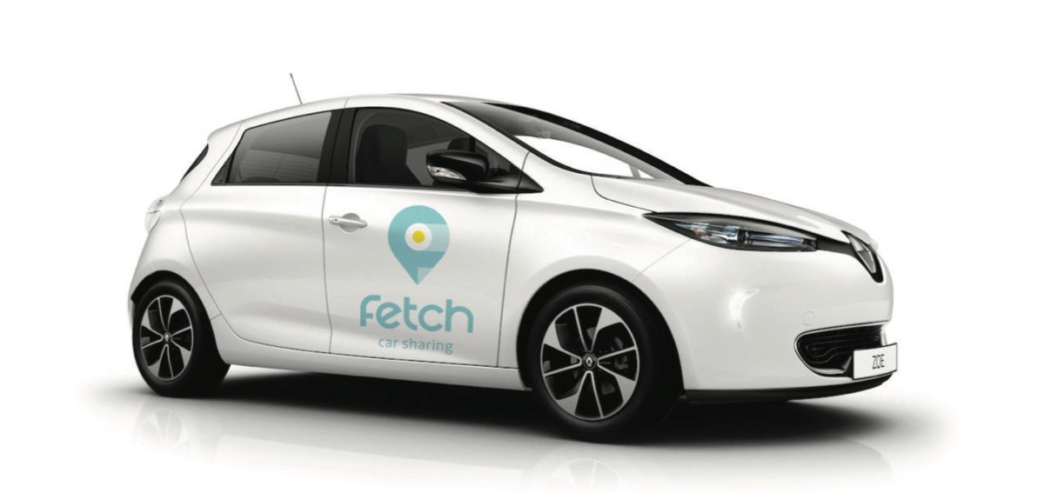

Fetch Car Sharing Amsterdam
January 10th, 2019

Contents

- Introduction – new player on the car share market

- Fetch Car Sharing

- Renault as experienced partner in car sharing service

- Renault ZOE – the ideal shared car

Introduction

New player on the car sharing market
Fetch Car Sharing is a new entrant on the growing car sharing market in the Netherlands. The name may be new to everyone, but the same can't be said for the driving force behind this company. Fetch Car Sharing is part of ELC European Lease Company, a leading, independent B2B specialist in the field of fleet, rental and leasing solutions for B2B parties at home and abroad.
Fetch Car Sharing will start operating a 100% electric car sharing service in Amsterdam on 10 January 2019 using cars supplied by Renault. The car powering this project is the Renault ZOE, which is ideally suited for car sharing and has full connectivity with the Fetch share system. One hundred cars will be operational from the start, with an additional one hundred Renault ZOE models being delivered in March.
Everything that has to do with searching, booking, unlocking and starting the car, through to signing off and payment, is done by smartphone. The shared cars use the ‘free-floating’ system, meaning that the cars don't have a fixed parking space, but can be picked up and returned anywhere inside the parking zone in Amsterdam. Users don't have to pay parking fees in Amsterdam as long as they abide by the city's regulations. A team of staff ensures the cars are recharged and ready to drive at strategic locations in Amsterdam.
The services of Fetch Car Sharing are based on three pillars.
- Convenience: registration, ease of use, straightforward all-in rates that are among the lowest in Amsterdam.
- Comfort: space and driving range.
- Freedom: to discover more (together) and to use at any moment.
Fetch Car Sharing has chosen the spacious Renault ZOE (five seats, five doors) because of its generous driving range of up to 300 km and its quick charging capacity thanks to the unique Caméléon battery. Furthermore, Fetch Car Sharing can rely on the knowledge and experience of Renault in the area of electric driving.
Fetch Car Sharing and Renault have a nationwide ambition. Their goal is to expand the car sharing service to a second major city in the Netherlands in the course of 2019.
More info: www.fetchcarsharing.nl

Fetch Car Sharing

Experienced player on the car sharing market
Fetch Car Sharing is a new entrant on the growing car sharing market in the Netherlands. The name may be new to everyone, but the same can't be said for the driving force behind this company.
Fetch Car Sharing is part of ELC European Lease Company, a leading, independent B2B specialist in the field of fleet, rental and leasing solutions for B2B parties at home and abroad.
Thanks to years of experience in car sharing, partly through the earlier car sharing project by its subsidiary Car4Share, Fetch Car Sharing has a wealth of knowledge and experience in how car sharing facilities are used.

How are the shared cars used?
A similar share service, which subsidiary company Car4Share set up around 14 months ago with already 100,000 or so car trips registered so far, has provided a lot of valuable data and a wealth of user experience.
During weekends, up to half of the shared cars with the driving range of the Renault ZOE make journeys outside Amsterdam, such as to the Efteling, the beach or other big crowd-pullers. By contrast, trips made during the week are mainly made to other cities, also for business purposes. The average distance travelled by car sharers is 20 to 25 kilometres, with the average hire period being 1 to 1.5 hours. A relatively large number of journeys start and end in the Amsterdam districts of IJburg, Zuidoost and West.

Who are the users?
Fetch Car Sharing bases its car sharing operation in Amsterdam. Car sharing is therefore initially intended for users who live in, work in or are temporarily visiting Amsterdam. It is therefore a mix of business and private customers of all ages, of which the large majority are between 20 and 40 years old.
Car sharing users have a clear need for flexible mobility. They are generally newcomers in urban areas. Compared to the average person in the Netherlands, they often have a high level of education and do not own a car. They are mostly one-person households or families with young children. Car sharers also tend to focus more on aspects such as convenience, cost saving, the environment and a solution to urban parking pressure.

How do you hire a shared car?
Fetch Car Sharing is all about user convenience. Every part of the car sharing process – registering, searching, booking, unlocking and starting the car, through to signing off and payment – is done on the Fetch app.
The app shows the user in real time a list of the available cars in Amsterdam. When a car is hired through the Fetch app, that same app also unlocks the vehicle. All that's left for the user to do is get in and drive away.
The shared cars of Fetch Car Sharing can only be returned in Amsterdam. The main reason for this is that there is no overarching parking permit available in the Netherlands. Once in Amsterdam, however, the cars can be left on any parking facility within the designated parking zone or return area, as long as the applicable parking regulations are met. In that case, the customer doesn't pay any parking fees.

How do you pay and how much does it cost?
All payments are made through the Fetch Car Sharing app. The most obvious choice of payment is after use, per trip, by mobile banking app. Another possibility is to authorise Fetch Car Sharing to automatically charge the car sharing fee to a credit card.
Fetch Car Sharing uses different rates.
- Trips lasting less than one hour cost 30 eurocents a minute.
- Trips taking more than one hour cost 26 eurocents a minute for the duration of the trip.
- For hire periods of longer than 5 hours, the costs per minute no longer apply and a daily rate of 78 euros automatically comes into effect, with a maximum rental period of 24 hours after the starting time.
- The maximum rental period is three days with a charge of 3 x 78 euros.
The above rates apply with a maximum driving distance of 150 kilometres per journey or per day. For every additional kilometre travelled, the user pays a surcharge of 25 eurocents per kilometre.

How does the recharging the electric shared car work?
The Renault ZOE of Fetch Car Sharing is fully electric. This means there is a good chance the car will be recharged at a charging station during use. The customer can disconnect the car easily and place the charging cable in the boot.
The car comes with a universal charge card, which can be used to recharge at a public charging point in the Netherlands, Belgium and Germany, or at any Fastned fast charge station. The advantage of using the Renault ZOE is its incredibly fast charging speed at regular recharging points, offering an additional driving distance of 65 up to 130 km per charging hour. This is two to three times higher than electric cars in the same class. Charging at Fastned offers extra driving distances of around 130 km per charging hour. Experience has shown, though, that the driving range of these electric cars is in almost every case enough for the entire journey made by an individual customer.
When the remaining battery charge of a shared car indicates under 30 kilometres’ driving distance, the Fetch app alerts the driver to recharge the car at a nearby charging point. If a car sharing journey is signed off with less than 20 kilometres left on the gauge, the car in question will no longer be visible in the Fetch app for the next user. Only after a driving range of 40 kilometres is reached will it be displayed in the Fetch app again, allowing the next user to drive away without having to recharge immediately.

High level of service
An integral part of the daily business operation at Fetch Car Sharing is the high level of service. Customers have access to readily available and helpful customer service staff, all directly from the app. The customer service department is made up of expert staff who know everything about the car sharing service and the cars.
A dedicated team is also at hand to clean and recharge the shared cars. The staff make sure the batteries of the shared cars have sufficient power at all times and that the cars are parked at strategic locations in Amsterdam. Thanks to the know-how and expertise with other car sharing projects, Fetch Car Sharing knows where most car sharing activity takes place. This adds to the convenience for customers who want to hire a shared car quickly and easily.
“We are noticing that drivers in major, busy cities attach increasing value to car use rather than car ownership. Shared cars like the ones at Fetch Car Sharing have become an intrinsic form of mobility for today's working population, residents and visitors of cities. The use of shared mobility for commuter travel, family visits and longer trips broadens the social mobility that is otherwise limited due to parking scarcity”, Marco Boender of Fetch Car Sharing explains.

Renault as experienced partner in car sharing

Renault largest provider of electric shared cars
With Renault as its mobility partner, Fetch Car Sharing has the advantage of working with the leading global provider of vehicules for carsharing in Europe. The French automotive giant now has more than 5,000 electric shared cars driving in different major European cities. Cities like Paris, Madrid, Stockholm, Copenhagen, Bologna, Rome, Warsaw, Oslo already preceded Amsterdam. Moreover Renault is leader on the EV market in Europe, 1 out of every 4 electric cars is a Renault.
The proactive working method of Renault is reflected in the setup of the ZOE that, among other benefits, allows car sharers to connect their car sharing technologies perfectly.

Nationwide ambition of Fetch Car Sharing and Renault
Entirely in line with current trends and developments, and with the joint ambition of Fetch Car Sharing and Renault, plans are on the table to expand the car sharing service to a second major Dutch city in the course of 2019.
Fetch Car Sharing aspires to be able to offer electric shared cars in more big cities in the Netherlands in the long term. A key issue – and this applies to the development of car sharing services on the whole – is the availability of an overarching parking permit that is valid in different cities, so that a shared car can be picked up in one city and dropped off in another. Partly thanks to the efforts of Renault and Fetch Car Sharing, this is now on the agenda of the parties involved.

Cooperation between Renault and We Drive Solar car sharing project
Since 2017, Renault has been working together with Utrecht-based company We Drive Solar and the city of Utrecht. Renault ZOE shared cars are now deployed in the Lombok district, the electricity of which is mainly generated from solar panels in the neighbourhood. Local communities can sign up for one ZOE, with a minimum of three users. It is a great solution for members of the community to share a car as well as the costs. Also the charging point is shared and just one parking space is needed. The goal of this initiative is to further develop the car sharing programme. There are currently 60 Renault ZOE cars driving in Utrecht and for Renault, the project serves as an important ‘living lab’ for building a knowledge base.

Renault ZOE: the ideal shared car

Why the choice for the Renault ZOE?
Fetch Car Sharing is starting with one hundred models of the Renault ZOE that are directly available in Amsterdam. An additional one hundred cars will be delivered in phases over the coming months. It is expected that all 200 shared cars of Fetch Car Sharing will be on the roads from the second quarter of the year. Renault is the supplier of the Renault ZOEs ordered by Fetch Car Sharing.

Large driving range
Fetch has chosen the Renault ZOE because of several specific benefits, the first being its generous driving range. According to the new, real-world WLTP consumption and range tests, the Renault ZOE can achieve a distance of about 300 kilometres on a fully charged battery. This is substantially more than the average car sharer needs. The large battery range means the Renault ZOE can be reserved by the next customer very quickly after being used, without the battery having to be recharged between hire periods.

Practical and versatile
Another reason for Fetch Car Sharing to choose this type of shared car has to do with practical usability. What's more, the car should also be relatively easy to park. The Renault ZOE, with its length of four metres and short turning radius, is incredibly versatile and easy to manoeuvre in tight spaces. At the same time, it boasts five doors, five seats and a spacious boot with a volume of 338 litres. This makes the Renault ZOE also ideally suited for families who want to go on weekend trips out of the city. So, it's really no surprise that the Renault ZOE is the top-selling electric car in Europe. The Renault ZOE is the only electric shared car in Amsterdam that can comfortably seat more than two people.

Unique Caméléon battery
Another important feature of the Renault ZOE is the unique Caméléon battery, which constantly adapts to the available capacity of the charging point, thus allowing you to always charge the battery at maximum power.
The Caméléon battery makes it possible to convert alternating current to a maximum of 22 kW direct current for speedier battery charging. No other car brand has yet been able to match the conversion of such high capacities of AC to DC. Charging with a capacity of 22 kW, which is equal to a driving range of 130 km per charge hour, is three to six times faster than any other electric car with the same capacity.

The ZOE can therefore rightfully claim to be the ideal shared car that often needs to be charged quickly.

Car sharing functionality
The Renault ZOE is factory delivered with special connectivity for car sharing providers. This enables the software and hardware of Fetch Car Sharing to flawlessly communicate with the ZOE and for the battery level and status of, for example, the door lock mechanism, to always be available.

