14 juni 2023 Persdossier

Conceptauto H1st vision van Software République:
mens-centrale visie op mobiliteit van morgen

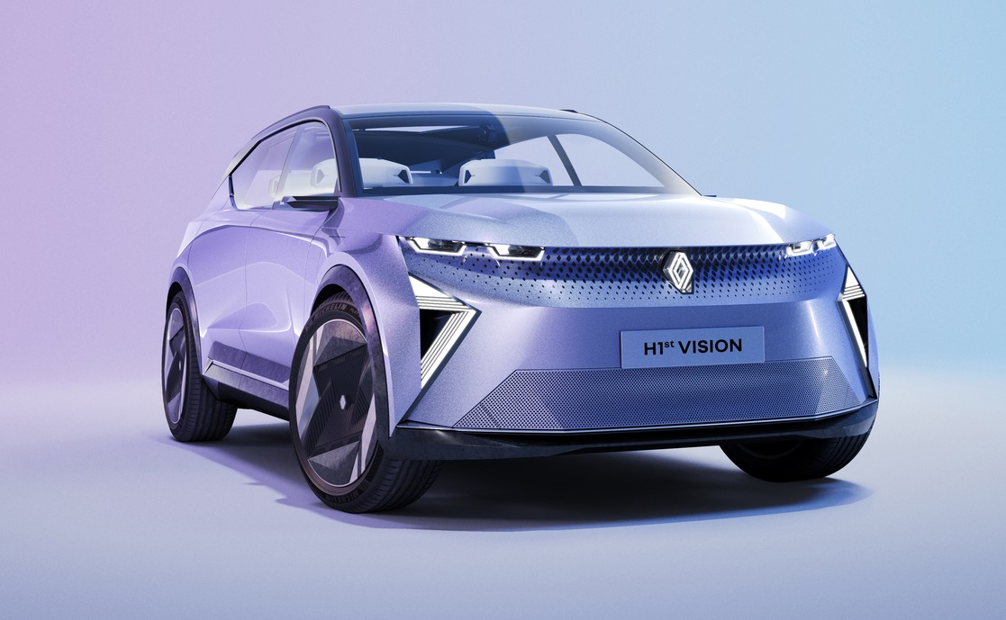

INHOUD
INTRODUCTIE 3
Twintig innovaties aan boord 4
De H1st vision-methode van Software République 4
A HUMAN-FIRST EXPERIENCE 6
Technology that revolves around the user 6
Device-free car access and Software République Avatar: simple and intuitive access 7
Immersive sound experience: a unique sound experience 8
Driver private Alert: a localised audible alert 9
Personalized call privacy: private phone conversations 9
Simpler mobility 10
Park & charge real-time access: intelligent parking and charging 10
In-car payment: payment on-board 11
Optimising energy 12
Vehicle to grid (V2G): intelligent two-way charging 12
Mobilize Powerbox: a smart two-way secure charging station made in France 13
STMicroelectronics silicon carbide: for more efficient electric mobility 14
Virtual twin: mobility interconnected in an ecosystem linking the virtual and real worlds 15
BETTER PROTECTING THE DRIVER AND OTHERS 16
The driver’s health 16
Health monitoring assistant: your car watches over you 16
E-mood assistant: your car gets to know you 17
Real-time health assistant and Satellite communication: satellite emergency call assistant 18
Car health 19
Predictive car health monitoring: vehicle condition monitoring 19
Car health NFT certificate: vehicle health certificate 20
For safer roads 21
Predictive risky zone alert: early warning of accident-prone areas 21
Real-time vulnerable road user protection 22
Predictive emergency vehicle alert 23
Cybersecurity: detection and response 24
The H1st vision concept car’s design 25

INTRODUCTIE
Software République is een open innovatie-ecosysteem gecreëerd door zes grote ondernemingen (Renault Group, Atos, Dassault Systèmes, Orange, STMicroelectronics en Thales). De samenwerkende partijen hebben duidelijke doelen gesteld om een ​​Europees ecosysteem voor duurzame, soevereine en veilige mobiliteit te helpen creëren. De ambitie is om tegen 2025 tien nieuwe diensten en producten te lanceren, meer dan vijftig startups te stimuleren en diensten in meer dan vijftig regio’s over de hele wereld aan te bieden.

Slechts twee jaar na de oprichting presenteert Software République een samenwerkingsconcept dat zijn wereldpremière beleeft op de Viva Technology 2023-tentoonstelling in Parijs: de H1st vision (Human First vision). Dit voertuig bevat functionele en innovatieve technologie die de mensgerichte visies op de mobiliteit van de toekomst van Software République illustreren. Het is een revolutie in mobiliteit die twintig concrete, operationele innovaties samenbrengt.

Het fysieke voertuig bestaat ook digitaal, waardoor een virtuele tweeling in een digitaal universum ontstaat waar systemen communiceren die momenteel onafhankelijk zijn (infrastructuur, energie, openbare diensten, gebruikers van verschillende categorieën). Dit maakt het mogelijk om de verschillende use cases die zich in de echte wereld kunnen voordoen, te modelleren, visualiseren en simuleren. Dankzij de onderlinge connectie met zijn omgeving staat de H1st vision voortdurend in dialoog met digitale en fysieke ecosystemen. Het biedt daarmee een ervaring die verder gaat dan automobiliteit.
De H1st vision is niet zomaar een conceptauto: het is een tastbare visie op de mobiliteitservaring van morgen.

Bij de twintig innovaties van dit technologisch zeer vooruitstrevend concept staat de mens centraal. Daarbij zijn alle innovaties operationeel: ze zorgen voor de bestuurder, de passagiers en andere weggebruikers. De H1st vision beschikt bijvoorbeeld over:

- Compleet nieuwe en veilige biometrische toegangscontrole
- Een unieke geluidservaring in de auto
- Geoptimaliseerde actieradius en laadprestaties
- Een gezondheidsmonitor en -assistent voor bestuurder en voertuig
- Voorspellende waarschuwingen om inzittenden en weggebruikers te beschermen
De H1st vision zit boordevol expertise van de leden van Software République, bestaande uit grote spelers en veelbelovende startups die zijn geselecteerd vanwege hun unieke kwaliteiten. Het voertuig is in een recordtijd van slechts zes maanden ontwikkeld door een team van honderd mensen. Met de functionele, virtuele en fysieke conceptauto demonstreert Software République hoe de relevantie van het open innovatiemodel kan resulteren in industriële projecten die helpen om van Europa een prominente hub te maken voor de mobiliteit van de toekomst.

“De conceptauto H1st vision is een verbonden, fysiek en virtueel object dat niet alleen een robuuste methode voor samenwerking tussen de partners demonstreert, maar ook hoe technologie van Renault Group, Dassault Systèmes, Orange, ST Microelectronics en Thales elkaar aanvullen om de mobiliteit van de toekomst vorm te geven.”
- Eric Feunteun, Chief Operating Officer, Software République

Twintig innovaties aan boord
De H1st vision brengt baanbrekende mobiliteitstechnologie samen, gericht op de veiligheid en het welzijn van de inzittenden en de omgeving. Als je het voertuig nadert, activeert de H1st vision de gezichtsherkenningssoftware om toegang te verlenen tot het interieur en het voertuig op te starten. Een avatar die op het raam en vervolgens op de middenconsole wordt geprojecteerd, heet de gebruiker welkom en biedt ondersteuning voor alle beschikbare functies.

Het meeslepende audiosysteem, ontworpen met Jean-Michel Jarre, geeft gebruikers het gevoel in een cocon te verblijven. De combinatie met een innovatieve microfoon zorgt voor
een ruimtelijke geluidszending en -ontvangst op elke zitplaats. De H1st vision biedt ook een betaalinterface en een slimme parkeerassistent.

Voor het verder verduurzamen van mobiliteit en het verbeteren van de efficiëntie zijn onderdelen van siliciumcarbide gebruikt voor de belangrijkste aandrijfsystemen van elektrische voertuigen en in het laadsysteem. Zogeheten Powerbox-laadstations werken in beide richtingen (V2G, Vehicle-to-Grid), dus de auto kan ook het elektriciteitsnet ondersteunen of je woning van stroom voorzien tijdens piekuren.

Een arsenaal aan fysieke en virtuele sensoren waakt over de gezondheid van de inzittenden. Bij een incident kan de H1st vision zelfs hulpdiensten oproepen via mobiel of satelliet. Het systeem controleert ook de slijtage van belangrijke voertuigonderdelen, zoals de accu of de banden. De H1st vision kan zelfs een eigen gezondheidscertificaat genereren.

De virtuele tweeling van de H1st vision toont de uitgebreide connectie van de auto met zijn omgeving (stad 4.0, andere mensen die de weg gebruiken, andere infrastructuur, etc.) om potentiële gevaren te herkennen, mensen veilig te houden als ze kwetsbaar zijn en de doorstroming van hulpdiensten te optimaliseren.

De H1st vision-methode van Software République
De innovatieve aanpak en bundeling van expertise door de samenwerking van de zes oprichtende leden heeft geleid tot de toepassing van twintig slimme technologieën in een uniek concept. En dat in een recordtijd van slechts zes maanden.
Het voertuig is uniek doordat het de technologie van de leden en andere spelers samenbrengt, waaronder zeven startups en partners: Arkamys, Compredict, Epicnpoc, Eyelights, Kardome, Stern Tech en JCDecaux. Het studiemodel is ook uniek doordat het een fysiek object combineert met zijn digitale tweeling, verbonden met zowel het object als zijn omgeving.

A HUMAN-FIRST EXPERIENCE
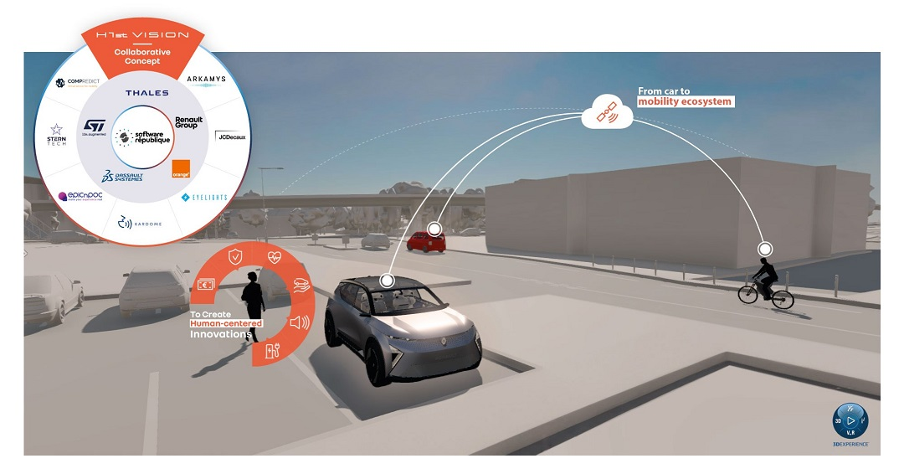Under its futuristic body, the H1st vision concept car is a human-centred technology demonstrator. It is interconnected, and designed for simpler, smoother and safer electric mobility.

Technology that revolves around the user
H1st vision is as advanced as it is simple and intuitive to use. This is because the user experience, rather than technical sophistication, was one of the main factors directing innovation.
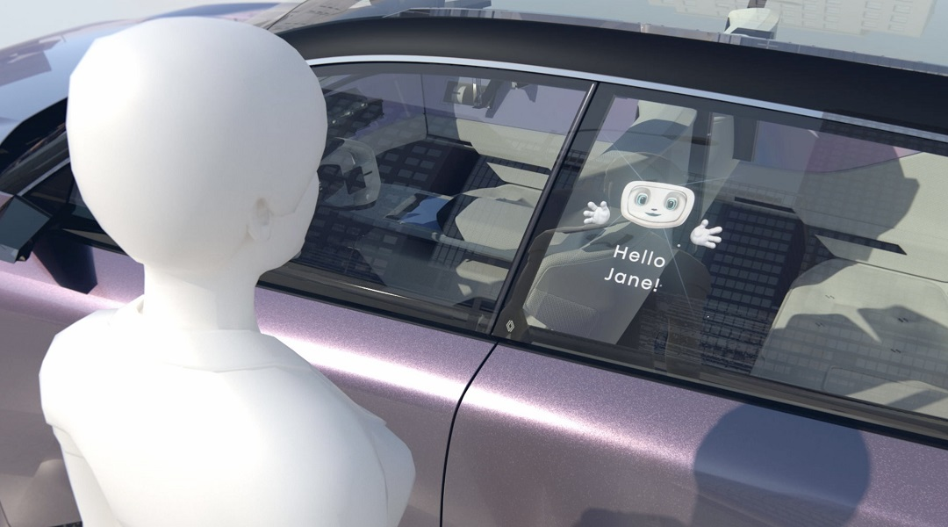
[Device-free car access and the Software République Avatar] Simple, intuitive access
Device-free car access technology is a simple and swift way to unlock the vehicle – without any hardware! You don’t need to hold your smartphone in your hand or carry your card or key in your pocket, the access control mechanism is ironclad, and the experience is effortless and seamless.
You open H1st vision remotely using two cutting-edge authentication technologies. Users create a profile on a tablet beforehand. Their data (name, height, a photo of their face and a video of them walking) is encoded and stored in an ultra-secure virtual container integrated into the car, the Digital ID Wallet.
The vehicle recognises the registered driver and passengers approaching on either side, based on their posture (using cameras on the wing mirrors), when they are up to six metres away. Then it recognises their face up to three metres away (a camera on the centre pillar between the two doors switches on once the posture camera has checked their gait).
These two authentication technologies complement each other and green-light the users using a maximum-security protocol. A projector built into the front headrest displays Software République’s avatar on the rear window, greets the user by name and asks them if they want to step in.
All the user has to do is say “Yes” and the door opens. Then the avatar is displayed on the dashboard screen. The camera in the windshield mirror identifies the driver and any passengers accessing the vehicle, and enables ignition based on the credentials in their profile. The driver or passenger seat automatically moves back or forth to the right position for the person the car has identified.
This novel authentication system helps to simplify car rental, sharing, pooling and driving licence checks.

Technologies used:
- Facial and gait recognition system: Thales
- Digital driving licence: Thales
- Cybersecurity: Thales
- Orchestrator: Thales
- MEMS microphone (voice recognition): STMicroelectronics
- CMOS (high dynamic range) image sensor: STMicroelectronics
- Microcontroller with integrated cryptographic accelerator: STMicroelectronics
- Window projection: EyeLights
- Door opener and seat position adjuster: Renault Group

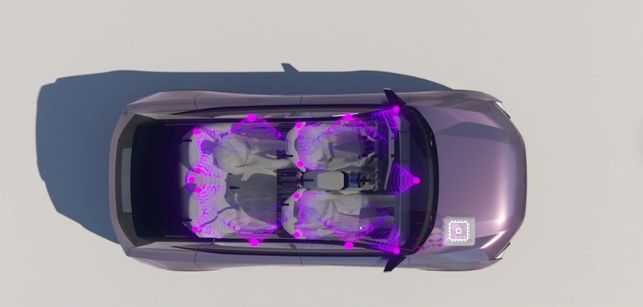
[Immersive sound experience] A unique sound experience designed with Jean-Michel Jarre
The H1st vision concept car is a true sound cocoon: its hi-fi system features 16 loudspeakers (a woofer in each door + a tweeter in each front door + two surround tweeters in each of the four headrests + a central channel + a subwoofer). This innovative audio system has been enhanced by Arkamys' expertise in signal processing and has been fine-tuned with Jean-Michel Jarre to deliver an outstanding immersive sound experience, which you can enjoy with two of the artist's tracks.
In addition to the quality of the sound output, this system enables flawless positioning of sound transmission and reception.
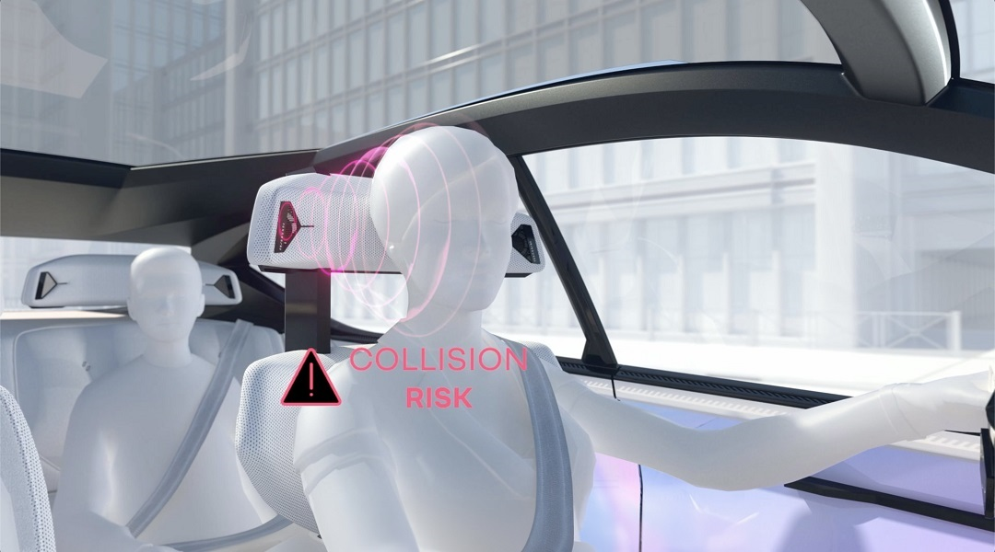
[Driver private alert] A localised audible alert
Spatialised sound enhances on-board safety. For example, one of the two tweeters in his headrest (the one on the side where a hazard could occur) will audibly alert the driver of an approaching emergency vehicle.

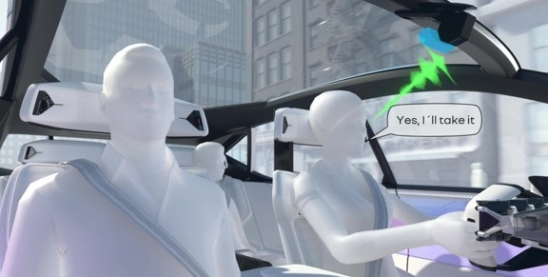
[Personalised call privacy] Private phone conversations
Sound emission and reception are spatialised inside H1st vision. The Kardome software system can identify the person speaking and locate them in the passenger compartment. That way, it can route sound to the speakers in that passenger’s headrest (there are two tweeters per seat). Each passenger, in other words, has their own personal sound space, for example to make a phone call.
The possible extensions of these features include immersive musical creations – for instance the two tracks by Jean-Michel Jarre sampled especially for the H1st vision concept car.
Technologies used:
- Integration into the car: Renault Group
- Sound spatialisation and architecture: Arkamys
- User identification and locating software: Kardome
- Power amplifiers (AB and D classes): STMicroelectronics

Simpler mobility
The H1st vision concept car is designed to simplify everyday mobility in general – and electric mobility in particular. The technologies on board can for instance locate, book and pay for a parking space remotely.
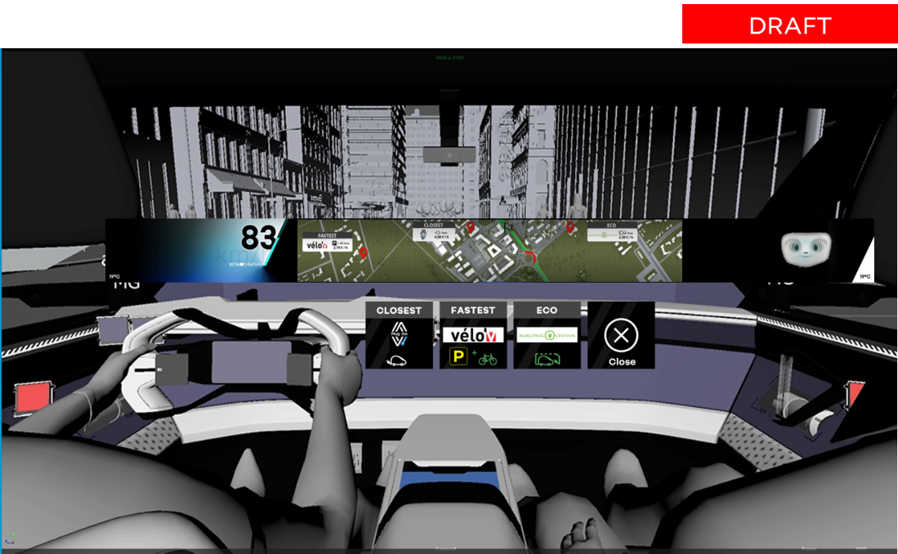
[Park & charge real-time access] Intelligent parking and charging
By pinpointing available parking spaces and charging stations using intelligent sensors coupled with data from connected vehicles and mobility service operators, H1st vision offers users a choice of three services depending on their needs:
- Closest: the spot nearest their final destination, for example a home terminal using the Plug Inn application
- Fastest: a spot near public or other modes of transport. Multimodal travel reduces carbon footprints and may help to ease congestion. To facilitate the user's journey, H1st vision for example includes self-service bicycle rental stations operated by partners near public car parks
- The most economical: for instance a V2G-compatible charging point (see page 11)
Technologies used:
- Connected vehicle data and data on available charging stations: Mobilize
- Plug Inn app (a French peer-to-peer EV charging community): Renault
- Smart parking space sensors: Orange
- Module combining Narrowband IoT (NB-IoT) cellular communication and localisation by satellite (GNSS): STMicroelectronics
- Self-service bicycle rental service: JCDecaux

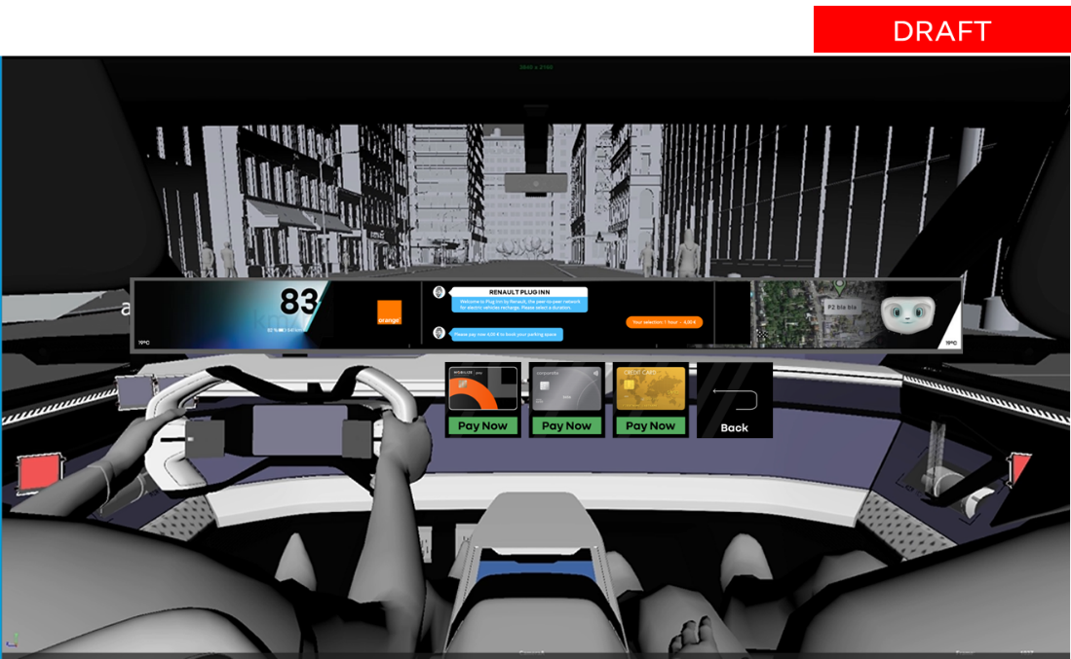
[In-car payment] Payment on-board
Park and charge services can be booked remotely and paid for in advance via a chatbot (a single interoperable enhanced messaging interface).
This interface is standard and universal. Service providers can have actual conversations with the vehicle’s user through the enhanced messaging service.
The secure system in the car releases payment and displays a receipt on the dashboard. So you can for example pay to charge your battery without stepping out of the car.
Payment is secured via Mobilize Wallet, a quick and safe service that can be used instead of several credit cards, tags and apps.

Technologies used:
- Open messaging platform enabling booking and payment via chatbot: Orange
- Application programming interfaces (APIs)/Software development kits (SDKs) for service providers: Orange
- Mobilize Wallet: Mobilize

Optimising energy
H1st vision takes care of its occupants and the environment. Its V2G compatibility means it can be charged smartly at Powerbox stations and return electricity to the grid when needed. Its battery chemistry is state-of-the-art for improved range and charging.
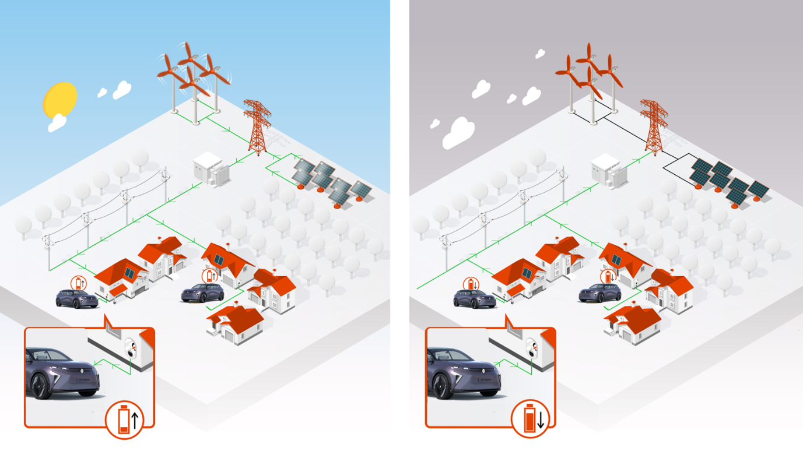
[V2G] Vehicle to grid: intelligent two-way charging
The H1st vision concept car has built-in two-way charging technology – G2V or V2G – so you can even use your car to power your home during consumption spikes. This smart energy management system liaises with its ecosystem and helps to manage costs during consumption spikes and to optimise use of renewable energies when the electricity supply contract so provides. Electric vehicles, in other words, double up as solutions to decarbonise the power grid.
This innovation will be implemented in the next generation of Renault vehicles, including the future Renault 5. Marketed in 2024, this will be the first car to be equipped with V2G technology.
Technologies used:
- 4G telecommunication: Orange
- Vehicle charging system and Mobilize Powerbox digital ecosystem: Renault Group
- Microprocessor, microcontroller with crypto coprocessor, powerline communication component, metrology device: STMicroelectronics
- Cybersecurity: Thales

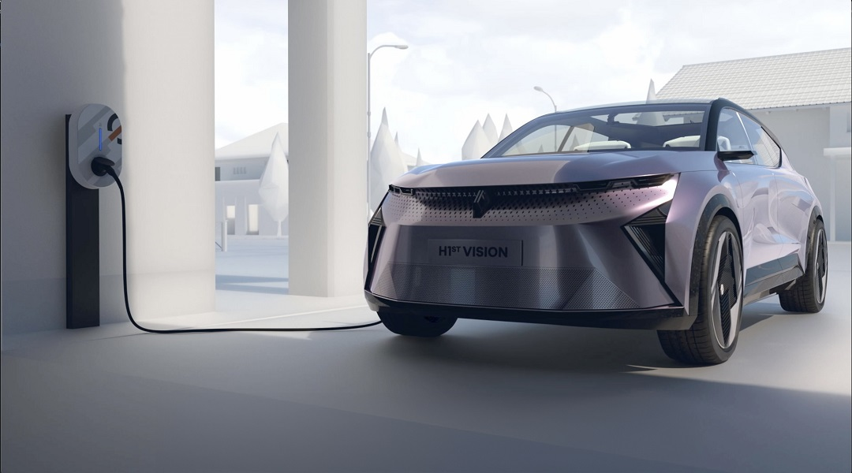
[Mobilize PowerBox] A smart two-way secure charging station made in France
PowerBox encompasses a range of smart, connected and secured 7, 11 or 22 kWh AC charging stations. These chargers include V2G technology and will be marketed by Mobilize Power Solutions in particular. You can use an app to operate them remotely.
Technologies used:
- Microprocessors, microcontroller with crypto coprocessor, powerline communication component, metrology device: STMicroelectronics
- Cybersecurity, data protection and connectivity module: Thales
- Digital tools (platform and app): Renault Group
- Telecommunication: Orange

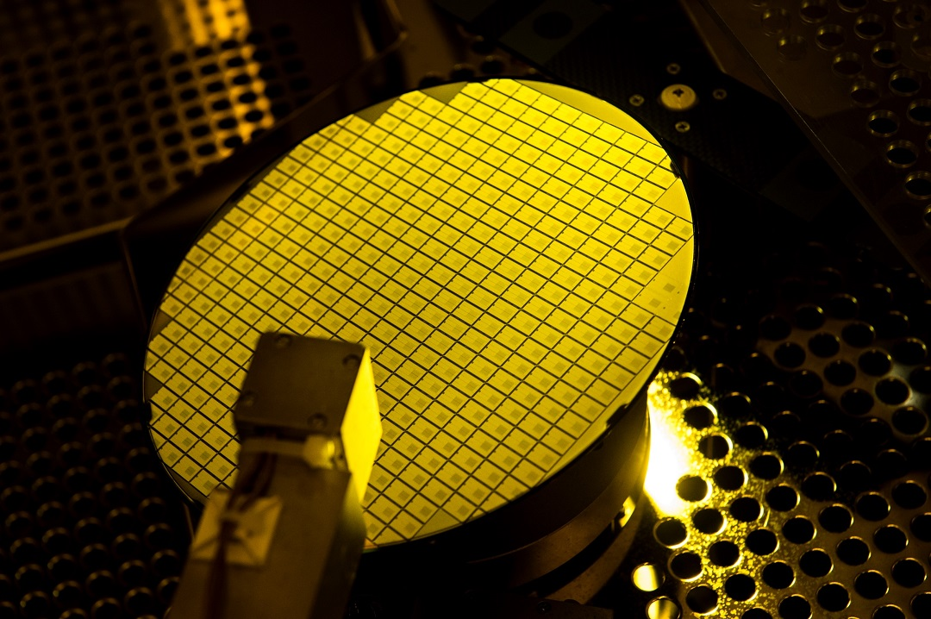 [STMicroelectronics silicon carbide] For more efficient electric mobility
Silicon carbide components are used in the critical systems powering electric vehicles – i.e. the inverters, in-car chargers and DC-DC converters. And they significantly increase efficiency at charging stations. Compared with traditional silicon equivalents, these components:

- Increase vehicle range or reduce battery size
- Lighten vehicles
- Lengthen battery life by easing pressure on it
- Considerably shorten charging time (50% less energy loss)

This innovation will be implemented in the next generation of Renault vehicles.

[Virtual twin] Mobility interconnected in an ecosystem linking the virtual and real worlds
For the first time worldwide, the H1st vision concept car blends into an ecosystem encompassing the vehicle and its virtual twin, interacting with each other in their real or virtual environment – with the driver and passengers but also all the mobility systems including other vehicles, alternative transport options, smart road infrastructure, connected car parks and charging stations, etc.
Virtual twins have become essential in groundbreaking innovation. They have revolutionised working methods by making it possible to design, simulate, test and optimise new products, services, processes, materials and experiences much faster, and on a much larger scale, before manufacturing them.
H1st vision’s virtual twin was used to simulate many innovations including security alerts associated with V2X (Vehicle-to-Everything) technology and carpooling passenger access. It enabled all partners to visualise and understand the impact of every decision they weighed while designing the various breakthroughs and optimising their system’s operation. Thanks to it, all partners involved in the H1st vision project were also able to “talk” with one another in the cloud, in real time, and share a comprehensive, up-to-date database.
H1st vision also treats users to a new kind of experience by connecting the virtual and physical worlds. In its digital environment, the virtual twin enables visualisation of H1st vision in real time all the time. This permanent link enables you to control the vehicle physically, for an enhanced and optimised mobility experience.

Technologies used:
- 3DExperience platform, and Catia and 3DExcite applications: Dassault Systèmes
- Biometric data processing and analysis system: Thales
- V2X platform and data: Orange
- BOWL platform with virtual-physical link: Epicnpoc
BETTER PROTECTING THE DRIVER AND OTHERS
Health and safety are top priorities for everyone. The technology developed by an open innovation ecosystem such as Software République can play the role of guardian angel. The H1st vision concept car is packed with pioneering technology to make mobility safer for the people in it and everyone else on the road.

The driver’s health
H1st vision is pioneering a new active safety system: monitoring the driver’s health and providing assistance. The technology goes beyond the ADASs in modern cars: it enables medical care as well.

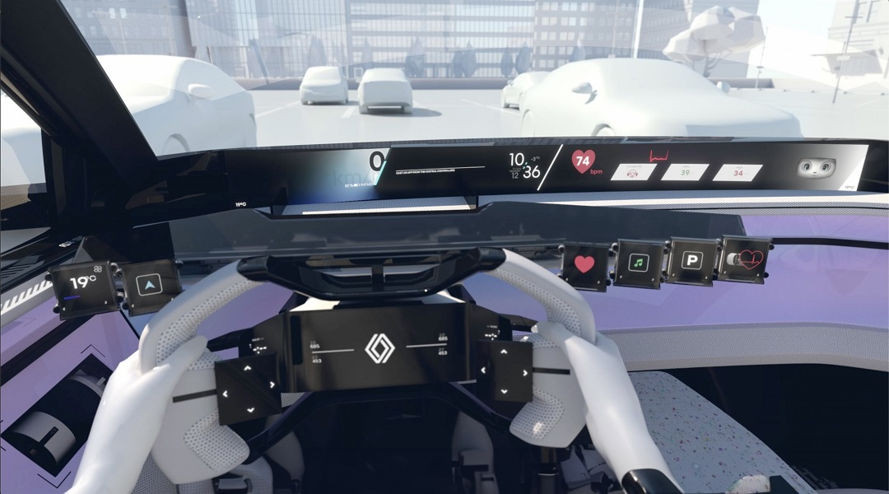
[Health monitoring assistant] Your car watches over you
Sensors in H1st vision concept’s steering wheel unintrusively monitor the driver’s heartbeat, any changes in it and its pattern. Another sensor, in the seatbelt this time, analyses their breathing rate. This information about the driver’s health is displayed on the dashboard. Over time, the system checks the driver’s data at any point in time against its “usual” profile. Following analysis, H1st vision concept informs the occupant of their health status. The Avatar makes suggestions (to adjust temperature or light inside the vehicle, for instance) or offers other advice that may help them feel better. For example, the avatar may prompt a passenger to do a breathing exercise.

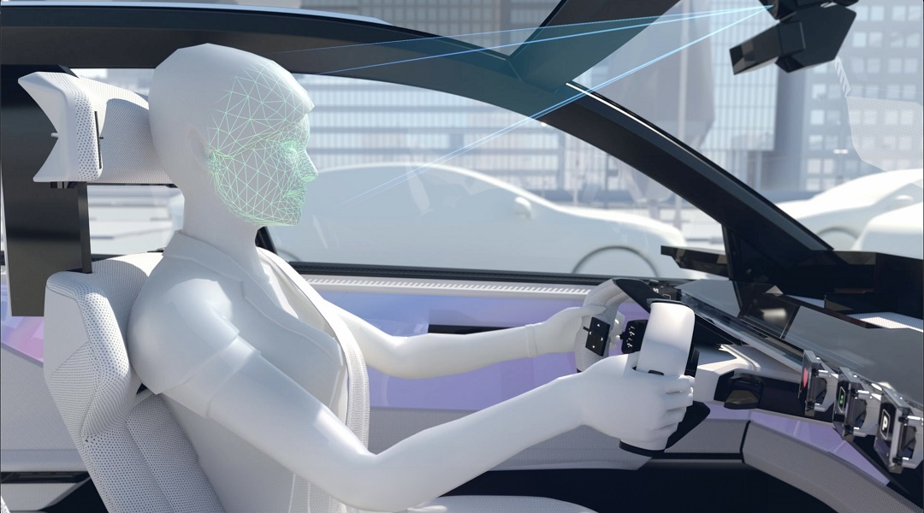 [E-mood assistant] Your car gets to know you
The in-car camera and the microphone under the windshield mirror discern the driver’s mood by analysing their voice and facial expressions. The avatar’s look, the colour of the onboard strip and the screen adjust accordingly.
If the e-mood technology detects that the driver is irritated or stressed, it will suggest a breathing exercise to help them relax.
Technologies used:
- Mood analysis software: Stern Tech
- Inertial module MEMS in the steering wheel to monitor the heart's electrical signals and accelerometer in the seatbelt to monitor the heartbeat, operation amplifiers, microcontroller with Bluetooth connectivity and power components: STMicroelectronics

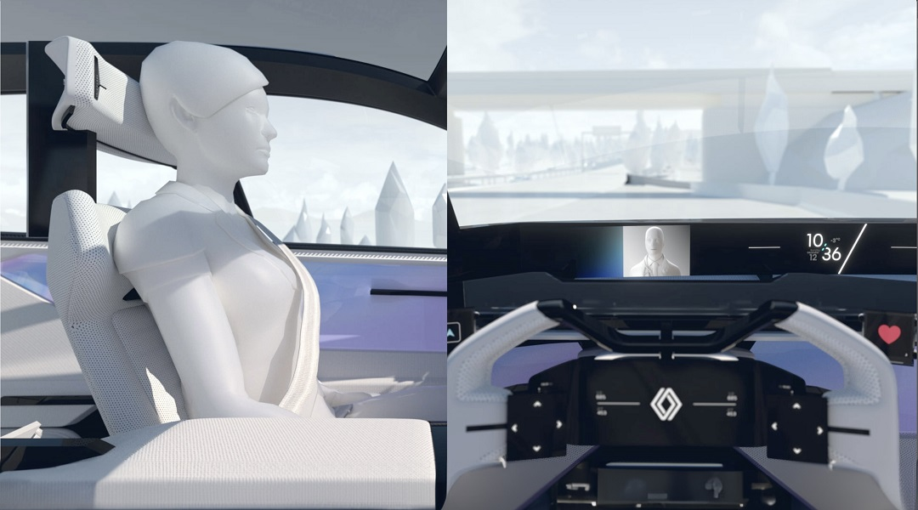
[Real-time health assistant and satellite communication] Satellite emergency call assistant
H1st vision's health monitoring assistant analyses the driver's health data. Thanks to its algorithms and user’s health track record, it can potentially step in before the driver is unfit to drive and suggest that he or she take a break. During the break, the health data can be sent to a medical assistance service, with the driver’s consent, and the system can set up a videoconference for a live conversation with a medical professional. The H1st vision concept car can also place a satellite call from a dead zone (an area with no mobile network coverage) using the shark fin antenna on the roof, to alert emergency services if someone in the car is unwell. Concurrently, it flashes its front and rear lights.
H1st vision can also place a call in areas covered by the terrestrial cellular network. Its multi-connectivity, in other words, provides seamless service everywhere.
A smart flashing beacon can also be fitted onto the roof to automatically send the vehicle’s position of the road traffic supervision centre over the cellular network.
Technologies used:
- Inertial module MEMS in the steering wheel to monitor the heart's electrical signals and accelerometer in the seatbelt to monitor the heartbeat, operation amplifiers, microcontroller with Bluetooth connectivity and power components: STMicroelectronics
- Integration into the car: Renault Group
- Satellite calls: Thales and Orange
- Module combining Narrowband IoT (NB-IoT) connectivity and localisation by satellite: STMicroelectronics

Car health
The innovation-packed H1st vision uses its technology to give drivers greater peace of mind regarding the state of operation and wear of its key components. This is reassuring for current owners, as well as future owners if the car changes hands.

[Predictive Car health monitoring] Vehicle condition monitoring
The H1st vision concept includes all-new virtual sensors, which can assess wear in the vehicle’s key components (battery, brakes, tyres, gearbox, chassis, suspension, etc.) in real time.
Complementing the physical sensors already fitted into today’s vehicles, the virtual sensors provide information enabling extremely detailed analysis.
By accurately monitoring the state of wear of the vehicle’s key components, the H1st vision concept generates:
- “health status”, a general snapshot of the vehicle’s health, available anytime;
- “health forecast”, an estimate of the number of kilometres the vehicle can drive before it needs servicing (based on sensor readings, not one-size-fits-all maintenance contracts), and advice to extend wearing-part life.

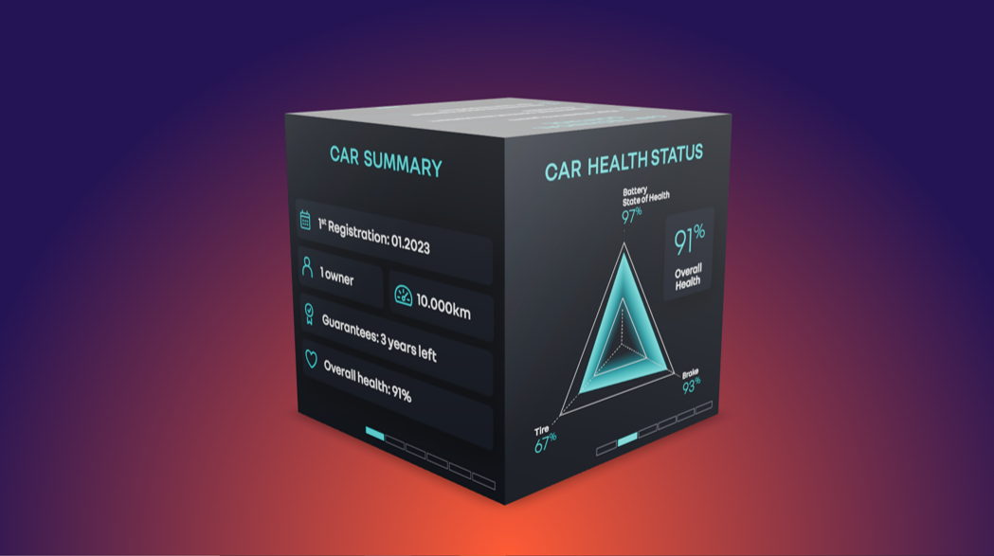
[Car health NFT certificate] Vehicle health certificate
The H1st vision concept car can generate its own “health certificate”. This document is an NFT* available on all digital devices (for instance a smartphone). It attests to the car’s health and contains all the related records (number of owners, status of the battery and other key components, number of check-ups, certificates issued by the garages that serviced the vehicle, etc.). It also includes the list of past technical inspections and, most importantly, tells you when the next inspection is due.
The health certificate uses blockchain technology, which is tamper-proof. The fact that its authenticity is guaranteed is reassuring for future owners or rental professionals and increases the car’s residual value.
Technologies used:
- Virtual sensors and monitoring based on machine-learning and deep-learning technologies: Compredict
- The car’s past data and expert insight: Renault Group
- NFT/Smart contract: Renaissance
- Live Identity Wallet and blockchain: Orange
- Virtual twin/3DExperience platform: Dassault Systèmes
* Non-fungible token: a unique digital certificate of ownership, which cannot be copied, replaced, or subdivided.

For safer roads
The interconnected H1st vision concept car constantly processes data it obtains in real time from the entire connected ecosystem as well as archived data. Its software platform collects, shares and analyses information from the 4.0 city and road networks, as well as from other vehicles and road users, weather data, etc. The aim is to improve safety in and around the vehicle, in particular through predictive systems.
A simulation of this technology is available via the H1st vision concept car’s virtual twin "in" a virtualisation of a real city.

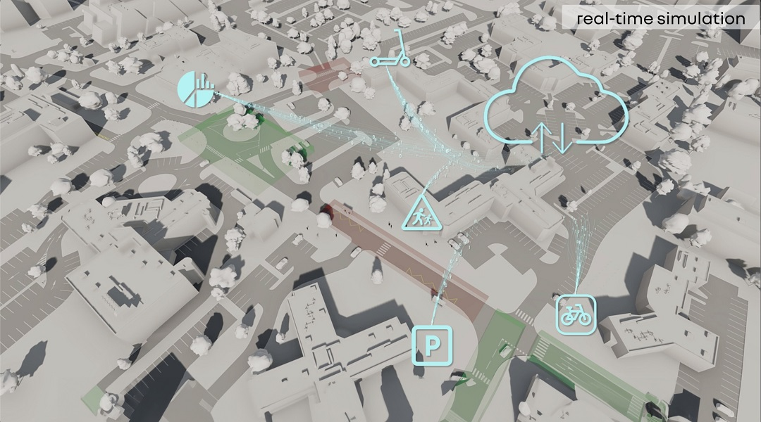
[Predictive risky zone alert] Early warning of accident-prone areas
The H1st vision concept uses accident statistics, the characteristics of the road and its environment (reduced visibility, intersections) to determine the probability of accidents. Capable of anticipating hazards such as accidents or the presence of black ice, it alerts the driver in real time via a display on the dashboard to increase the safety of the occupants and others, and protect the environment.
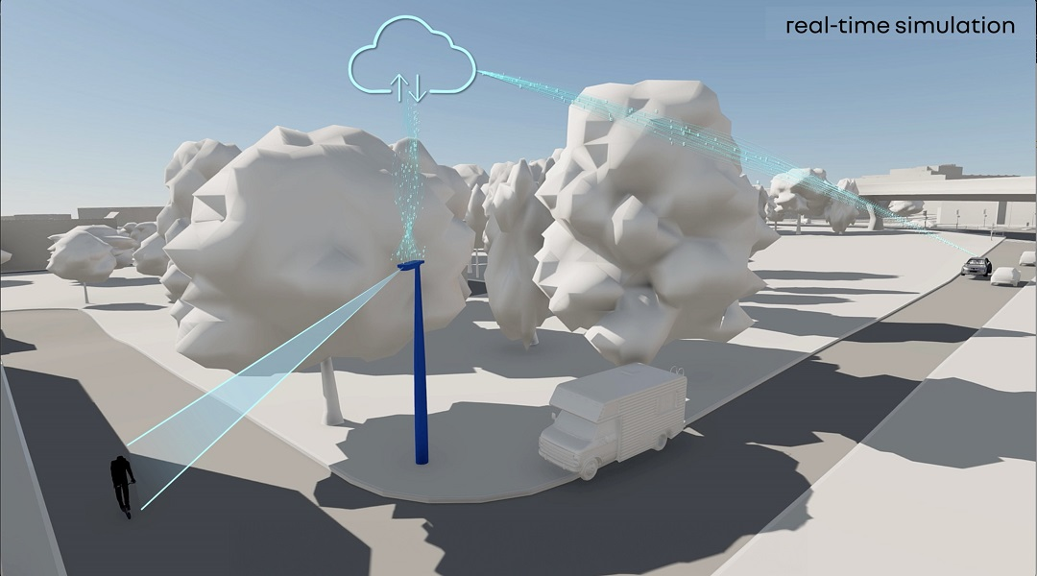 [Real-time vulnerable road user protection]
The H1st vision concept is hyperconnected to the entire mobility ecosystem. As it is connected in real time to the city, it uses data from infrastructure such as traffic lights and data from people using this infrastructure (for example in other cars, on scooters and on bicycles). The aim is to better protect all users with a system that alerts the driver of imminent danger in a timely manner, even when a vulnerable road user is in a blind spot or in an area with reduced visibility.

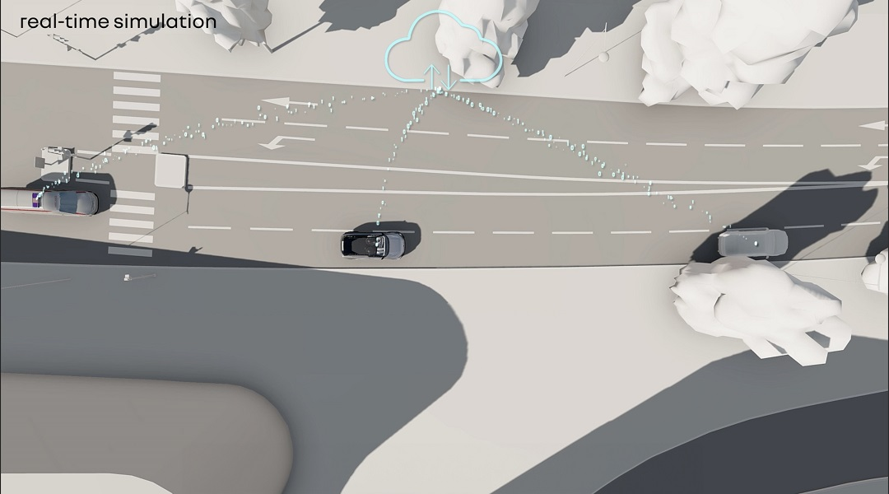
[Predictive emergency vehicle alert]
The congestion that builds up around accidents slows down emergency services trying to reach the area. As every minute counts when someone needs first aid or needs to be evacuated, V2X communication technology alerts the drivers of all connected vehicles that are slowing down or standing still that rescue vehicles are approaching. That way, drivers can help make way for the emergency vehicles to get through.
Technologies used:
- 5G connectivity, data and V2X platform: Orange
- Vehicle data and connectivity: Renault Group
- Secure V2V and V2X communication: STMicroelectronics
- Virtual twin: Dassault Systèmes

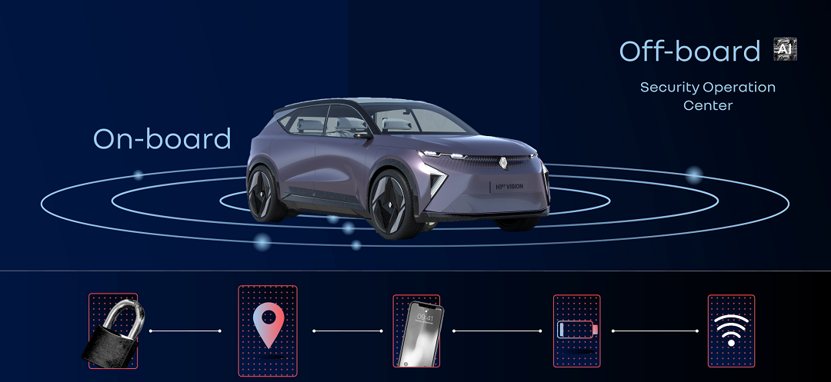
Cybersecurity: detection and response
Today, most new vehicles are connected. By 2025, nearly 85% of them will be connected in Europe (according to an S&P Global market study). To provide new functionalities and at the same time ensure maximum security, these intelligent cars will have an increased need for cyber-protection as well as risk detection and management. Cybersecurity is not an optional extra for connected and secure mobility. Orange Cyberdefense – the Orange group’s cybersecurity entity –, Renault Group and Thales jointly developed a unique solution to detect and respond rapidly to cyberattacks. This comprehensive solution is based on machine learning and other artificial intelligence technologies.
The complementary technologies from the three companies, integrated end to end, will make it possible to better identify cyberrisks and deal with them in all vehicle components and in the cloud, while meeting the most stringent applicable standards and regulations.
This unique solution shortens the time required to respond to cyberthreats: it detects the type of attack up to eight times faster, to anticipate and prevent risks more effectively. It will be implemented in the next generation of Renault vehicles.
Technologies used:
- 24/7 monitoring and analysis at the Security Operations Centre using IA/ML models: Orange
- Cyberthreat detection algorithms to build, maintain and improve IA/ML models: Thales
- Integration into the vehicle architecture: Renault Group

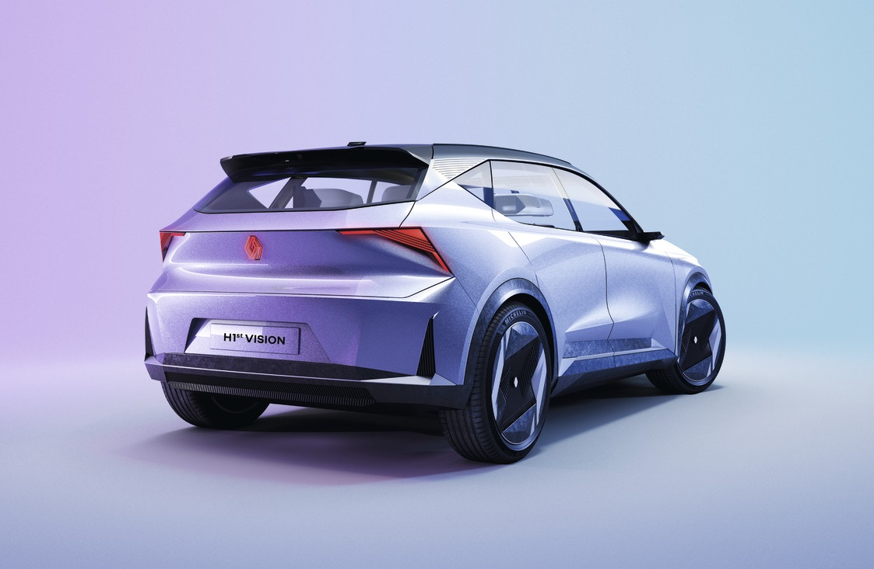The H1st vision concept car’s design
More than a demonstrator on wheels, H1st vision is a real vehicle that can seat four passengers in great comfort. The appealing design is a harmonious blend of smooth surfaces and sharp angles enhanced by a silver paint finish with purple varnish. Slim and stylish, the front and rear lights add a distinct techno vibe to the vehicle’s silhouette. And announce all the cutting-edge technology awaiting inside.
The shape of the rhombus runs through the design of H1st vision. The design of the rear lights is inspired by the new Renault logo.
Mirroring the looks of all-electric cars, the front has no air vents or air intakes. As if to deceive the eye, what appears to be a perforated grille is in fact an elegant checkerboard of Plexiglas diamonds through which LEDs emit coloured light. The LEDs also send out an interactive light signal that can alert pedestrians or indicate that the vehicle has come to an emergency stop.

About Software République:
The Software République is defined as an open innovation ecosystem dedicated to intelligent, secure, and sustainable mobility. It was created in April 2021 by six founding members: Atos, Dassault Systèmes, Orange, Renault Group, STMicroelectronics and Thales. The Software République builds collective businesses focused on tomorrow's mobility through its unique horizontal collaboration model. The ecosystem stands out for its innovative approach, combining established companies and startups from different backgrounds to bring to market products and services that meet the new challenges of the connected vehicle, the smart city and energy. These projects are based on the complementary expertise of its partners in data analysis, artificial intelligence, cybersecurity, connectivity, and virtual twins, and on the ambition to invent a new model of innovation while keeping people and the environment at the heart of its motivations. Further information can be found at https://softwarerepublique.eu/

