RENAULT GROUP noteert sterke cijfers in q3 2025: +6,8% MEER OMZET
PERSBERICHT
23-10-2025

Schiphol-Rijk, 23 oktober 2025 – Renault Group realiseerde in het derde kwartaal van 2025 een omzet van € 11,4 miljard, een stijging van 6,8% ten opzichte van dezelfde periode vorig jaar. De wereldwijde verkopen stegen met 9,8% tot 529.486 auto’s, met een aanzienlijke groei op zowel de Europese als internationale markten. Op basis van deze prestaties bevestigt Renault Group zijn financiële vooruitzichten voor het volledige boekjaar 2025.

- Omzet over eerste negen maanden van 2025
  - Groepsomzet van € 39,1 miljard, +3,7% ten opzichte van 9M 2024, +5,1% tegen constante wisselkoersen¹
  - Omzet uit autoverkopen van € 34,3 miljard, +1,7% ten opzichte van 9M 2024, +3,1% tegen constante wisselkoersen¹

- Omzet over het derde kwartaal van 2025
  - Groepsomzet van € 11,4 miljard, +6,8% ten opzichte van Q3 2024, +8,5% tegen constante wisselkoersen¹
  - Omzet uit autoverkopen van € 9,8 miljard, +5,0% ten opzichte van Q3 2024, +6,8% tegen constante wisselkoersen¹

- Sterke commerciële prestaties van Renault Group
  - In Q3 2025 steeg de verkoop met 9,8% ten opzichte van Q3 2024, met 529.486 verkochte auto’s; de internationale verkoop steeg met 14,9% en de Europese² verkoop met 7,5%.
  - In de eerste negen maanden van 2025 steeg de wereldwijde verkoop van Renault Group met 3,8%, met 1.698.964 verkochte auto’s, en stond het concern op de derde plaats in Europa.

- Alle drie de automerken binnen de groep groeien³
  - Renault merk #3 in Europa; sterke prestaties in EV gedurende het jaar met meer dan 20% van de verkopen in Q3; Renault 5 E-Tech #1 in het EV B-segment; #2 in hybride (HEV); #2 in lichte bedrijfswagens (LCV); Clio #2 bestverkochte auto via alle kanalen in Europa. Renault merk #1 in Frankrijk.
  - Dacia bevestigde zijn focus op particuliere klanten en stond op #2 in personenauto’s (PC) voor retailklanten, #9 in Europese personenauto’s. Sandero #1 bestverkochte auto via alle kanalen in Europa.
  - Alpine verdubbelde zijn verkoopcijfers ten opzichte van de eerste negen maanden van 2024.

- Sterke enkelcijferige groei van de orderintake in Europa in Q3 2025 op jaarbasis
- Gezond niveau van de totale voorraad: 538.000 auto’s per 30 september 2025
- Introducties gepland in Q4 2025
  - Renault Boreal (C-SUV), Renault Kwid E-Tech, Alpine A390 (C-SUV) en Renault Clio 6 (eerste leveringen in Q1 2026)

- Renault Group bevestigt zijn financiële vooruitzichten voor 2025, geüpdatet op 15 juli 2025
  - Operationele marge van circa 6,5%
  - Vrije kasstroom tussen € 1,0 miljard en € 1,5 miljard

¹ Om de variatie in de geconsolideerde omzet tegen constante wisselkoersen te analyseren, berekent Renault Group de omzet voor de huidige periode opnieuw door de gemiddelde wisselkoersen van de voorgaande periode toe te passen.
² ACEA-reikwijdte
³ Tenzij anders aangegeven, worden de ranglijsten weergegeven over de eerste 9 maanden van het jaar

De rest van het bericht gaat verder in het Engels

“In a highly challenging environment, we continue to capitalize on our compelling and competitive line-up - spanning electric, ICE, and hybrid vehicles - driving a 6.8% increase in Group revenue this quarter. We also benefited from the strong performance of Mobilize Financial Services, our financial captive, which remains a strategic asset for both current operations and the Group's long-term ambitions. With the target to be the best in what we can control, we remain fully committed to our value over volume strategy, while maintaining strong focus on executing our cost-reduction roadmap. We confirm our full-year guidance, targeting a Group operating margin around 6.5% and free cash flow between €1.0bn and €1.5bn. In parallel, we are actively shaping our next mid-term plan, designed to accelerate the Group's transformation and unlock future opportunities.”
Duncan Minto, Chief Financial Officer of Renault Group. Boulogne-Billancourt, France, October 23, 2025

Commercial results highlights
In 2025 Q3, Renault Group achieved a 9.8% increase in registrations compared to the same period in 2024, with a total of 529,486 vehicles sold. Both international and European sales contributed to this performance, up 14.9% and 7.5% respectively. In Europe^{[4]}, passenger cars sales grew by 10.9%, outperforming a market up 7.5%, while LCV sales have shown improvement sequentially, yet remaining 7.1% below 2024 Q3. All brands were up (PC, Europe): Renault +5.5%, Dacia +16.1%, Alpine +306.4%.

During the first nine months of 2025, Group sales were up 3.8% reaching 1,698,964 vehicles, with the three brands growing. In Europe, PC sales were up 6.9% for a total of 1,003,085 vehicles sold. In the international market, Renault brand sales (PC+LCV) were up in Latam (+17.3%), South Korea (+213.7%) and Morocco (+46.3%), confirming the success of its International Game Plan.

Renault Group maintained its strategy:
- Value over volume commercial policy:
  - retail sales accounted for 58.4% of total sales in the five[5] main European countries (nearly 17 points above the market), with sequential improvement in Q3 at 63.8% of total sales (20 points above the market). 3 vehicles were in the top 10 retail sales in Europe: Sandero, Duster, and Clio.
  - residual values remained globally stable for both Renault and Dacia brands at the end of September 2025 compared to last year, being 5 to 11 points^{[6]} above main competitors in the five main European countries.
- Electrification[7] acceleration:

In the first nine months, Renault Group electrified vehicle sales rose by 58.6%, now representing 43.9% of total sales.
In 2025 Q3, Renault Group's electrified vehicle mix reached 44.0% of the total sales up 10.8 points compared to 2024 Q3.

  - EV: Over the first nine months, Renault Group EV share increased by more than 5 points to reach 12.7%. Renault 5 E-Tech was the B-segment EV leader in Europe.
In 2025 Q3, Renault Group EV sales grew by 122.1% compared to 2024 Q3, reaching 13.5% of sales.
  - Hybrid (HEV): Over the first nine months, Renault Group HEV share increased by more than
8 points to reach 30.4%. This increase is due to Renault and Dacia brands' successful hybrid line-up. Renault Group remained second for hybrid (HEV) vehicles in Europe.
In 2025 Q3, Renault Group HEV sales grew by 25.0% compared to 2024 Q3.

Renault Brand
In the first nine months of 2025, Renault sold 1,169,806 vehicles worldwide, marking a +3.8% increase, compared to the same period last year. In Europe[8], Renault PC recorded a +7.5% increase, the second-highest growth among top fifteen automotive brands, with 546,314 vehicles sold. The brand's PC market share rose by +0.3 points reaching 5.5%. Renault International Game Plan continues to deliver strong results, with +15.6% growth (PC+LCV) in the international market compared to last year.
In 2025 Q3, Renault delivered a strong performance, with 361,575 vehicles sold, a 6.6% growth compared to 2024 Q3.

Internationally^{[9]}, Renault grew in its strategic regions, posting a +14.2% increase overall. In Latin America, the brand rose by 6.8% thanks to Kardian with further momentum expected from the upcoming launch of Boreal in Brazil this November. In South Korea, Grand Koleos made the brand grow by 54.7% compared to 2024 Q3. In Morocco, Renault achieved a +42.6% growth, with 9,258 vehicles sold, again supported by Kardian's success.

In Europe, the brand grew by 1.8% (PC+LCV) thanks to a 5.5% PC growth and a LCV performance (-7.0%) showing signs of recovery following a challenging first half^{[10]} of the year. Growth was especially high in Germany (+27.9%) and in Spain (+11.9%).

Renault electrified[11] vehicles accounted for 60.0% of the brand sales (+9.6 points vs. 2024 Q3). Renault EV sales surged by +84.7%, to reach more than 20% of Q3 sales (+8.7 points vs. 2024 Q3) thanks to Renault 5 E-Tech, the B-segment EV leader in Europe, and Scenic E-Tech, the C-segment EV leader in France. Hybrid sales rose by +4.4%, thanks to Symbioz, the best-selling Renault hybrid, to reach 37.9% of the brand sales. Renault was the second brand for hybrid vehicles in Europe.

Over the first nine months, Renault EV sales were up 65.8% compared to the same period in 2024. Renault EV mix reached 17.4%, up 6.1 points compared to the same period in 2024.

Dacia Brand
In the first 9 months of 2025, Dacia brand sold 521,387 vehicles worldwide, up 4.1% compared to the same period in 2024. In Europe, with 449,634 passenger cars sold (+5.3%), the brand maintained its 9th position in the passenger cars market. It gained one place and was ranked 2nd on the European podium for passenger cars sold to retail customers, the brand's core customer base.

2025 Q3 marked an acceleration for Dacia with 165,451 vehicles sold (+16.2%), a strong increase compared to the first two quarters of 2025. The brand posted a solid growth in the majority of European markets, with remarkable performances in Germany (+23.6%), Spain (+19.3%) and Belgium–Luxembourg (+37.5%). This momentum was largely driven by the success of Bigster, the second best-selling C-SUV since June in Europe on the retail market, which recorded 22,353 registrations during Q3 and more than 39,700 since the beginning of the year. It also registered more than 55,000 orders since its launch. Dacia Sandero confirms its success by being the best-selling vehicle in Europe, all distribution channels combined, with 66,233 units sold in Q3 and 218,089 units since January.

With Duster and Bigster, Dacia is accelerating the pace of its electrification[11]. Hybrid sales more than doubled, now accounting for 20.9% of the brand's Q3 sales (+9.1 points vs. 2024 Q3). Over the first nine months, Dacia's hybrid sales jumped by 170.0%.

Alpine Brand
In the first 9 months of 2025, Alpine sales more than doubled compared to the same period in 2024, to reach 7,394 vehicles.

In 2025 Q3, Alpine recorded 2,344 registrations, compared to 625 registrations in 2024 Q3. The A290, the recently launched electric sports city car, is now available in almost all of the brand's countries, totaling 1,845 registrations over the period. The United Kingdom becomes the second largest market for the A290 after France. In addition, Alpine will soon open orders for the A390, its new electric sport fastback. The A110 maintained a solid momentum even if the orders of the current generation of A110 will close in the coming months before the arrival of the next generation 100% electric.

Third quarter revenue
Group revenue for 2025 Q3 amounted to €11,426 million, up 6.8% compared to 2024 Q3. At constant exchange rates^{[12]}, Group revenue was up 8.5%.

Automotive revenue reached €9,816 million, up 5.0% compared to 2024 Q3. It included -1.8 points of negative exchange rates effect (-€167 million) mainly related to the devaluation of the Argentinean peso, the Turkish lira, the Brazilian real and the Korean won. At constant exchange rates¹, it increased by 6.8%. This evolution was mainly explained by the following:
- A positive volume effect of +3.2 points. The 9.8% increase in registrations was partly offset by a higher destocking of the independent dealer network over the quarter compared to 2024 Q3 (destocking by 72k units in 2024 Q3 vs. 98k units in 2025 Q3).
- A positive geographic mix of +1.0 point, notably explained by lower sales in Brazil in 2025 Q3 due to a focus on the most profitable channels combined with a high comparison base in 2024 Q3.
- A positive product mix effect of +0.9 points explained by the performance of both Renault and Dacia models mostly Bigster and Renault 5 E-Tech. The lower product mix effect compared to the previous quarters is mostly explained by the annualization impact of the launches from the previous year. Product mix in Q4 should be higher, benefiting from a stronger contribution of Bigster and Renault 5 E-Tech, and the ramp-up of Renault 4 E-Tech.
- A negative price effect of -0.8 points mainly due to the market conditions in Europe that remain challenging with commercial pressure. Some of the negative currency impacts were offset by price increases. As part of its value over volume policy, the Group maintains, in its pricing approach, a strong focus on residual values, which is a key competitive factor for the Group's long-term performance.
- A positive sales to partners effect of +1.6 points, notably driven by programs with our partners and the impact of the integration of RNAIPL (Renault Nissan Automotive India Private Ltd) into the consolidation perimeter. On August 1st, 2025, Renault Group completed the acquisition of the 51% stake in the Chennai plant (RNAIPL), previously held by Nissan.
- A positive ”Other” effect of +0.9 points, primarily related to the performance of Retail Renault Group (RRG) activity.

Mobility Services contributed €23 million to 2025 Q3 Group revenue compared to €14 million in 2024 Q3.

Mobilize Financial Services posted revenue of €1,587 million in 2025 Q3, up 18.4% compared to 2024 Q3, due to higher interest rates and to the increase of average performing assets (at €59.5 billion) which improved by 5.3% compared to 2024 Q3.

As of September 30, 2025, total inventories (including the independent network) represented 538,000 vehicles, a level in line with the normal seasonal evolution:
- Group inventories at 219,000 vehicles
- Independent dealer inventories at 319,000 vehicles

Looking forward into Q4, the Group expects the restocking at independent dealers to be well below the one recorded in 2024 Q4.

The high single-digit growth of the order intake in 2025 Q3 year-on-year is fueling the orderbook in Europe, which stood at 1.6 months at the end of September given the strong forward sales expected in Q4.

2025 FY financial outlook

Renault Group confirms its 2025 financial outlook, updated on July 15, 2025:
- Group operating margin around 6.5%
- Free cash flow between €1.0 billion and €1.5 billion

Renault Group’s consolidated revenue
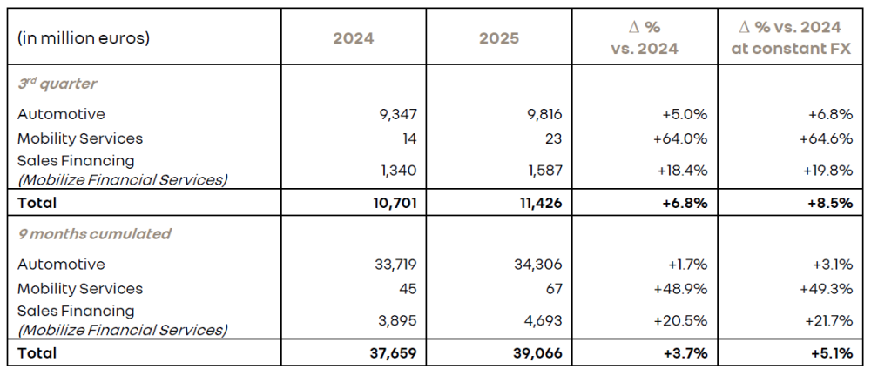

Total Renault Group PC + LCV¹ sales by brand
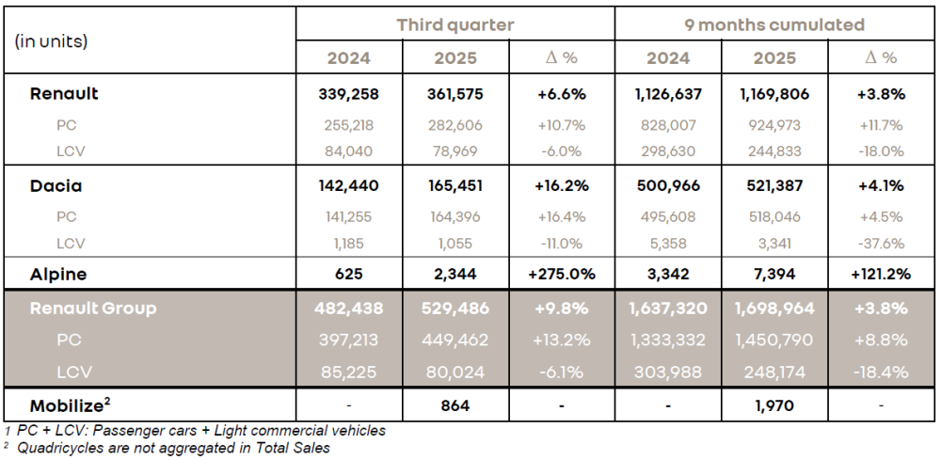

Renault Group’s top 15 market at the end of September 2025

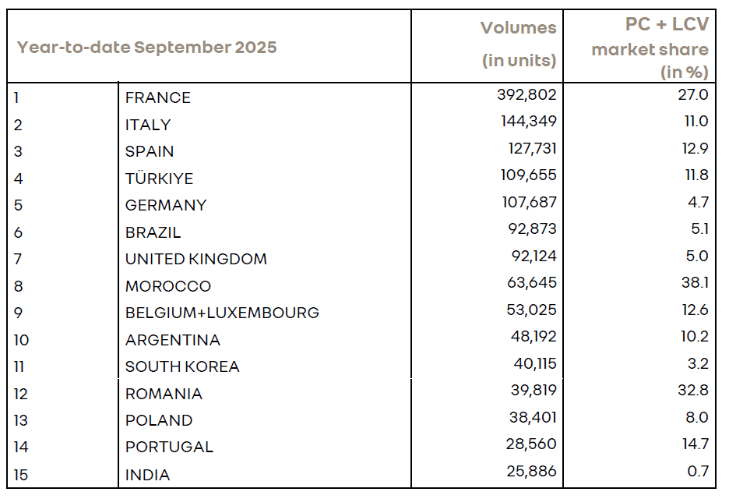

2025 Q3 Revenue Conference
Link to follow the conference on October 23, 2025, from 8:00am CEST and available in replay: 2025 Q3 conference streaming

⁴ ACEA scope
⁵ France, Germany, Italy, Spain, and United Kingdom
⁶ 22 main brands PC segment, France, Germany, Spain, Italy and United Kingdom
⁷ Scope: EV, HEV and PHEV passenger cars in Europe. Provisional data at the end of September 2025 based on the following European markets: Austria, Belgium, Croatia, Czech Republic, Denmark, Estonia, France, Germany, Greece, Hungary, Iceland, Irlande, Italy, Latvia, Lithuania, Luxembourg, Netherlands, Norway, Poland, Romania, Slovakia, Slovenia, Spain, Switzerland, United Kingdom
⁸ ACEA scope
⁹ Outside Europe
¹⁰ 2025 H1 Renault LCV sales declining by 29.9% vs. 2024 H1
¹¹ Scope: EV, HEV and PHEV passenger cars in Europe. Provisional data at the end of September 2025 based on the following European markets: Austria, Belgium, Croatia, Czech Republic, Denmark, Estonia, France, Germany, Greece, Hungary, Iceland, Irlande, Italy, Latvia, Lithuania, Luxembourg, Netherlands, Norway, Poland, Romania, Slovakia, Slovenia, Spain, Switzerland, United Kingdom
¹² In order to analyze the variation in consolidated revenue at constant exchange rates, Renault Group recalculates the revenue for the current period by applying average exchange rates of the previous period.
Over Renault Group
Renault Group loopt voorop met mobiliteit die zichzelf opnieuw uitvindt. De groep vertrouwt omvat vier merken – Renault, Dacia, Alpine en Mobilize – die elkaar aanvullen en duurzame en innovatieve mobiliteitsoplossingen bieden. Renault Group is actief in 114 landen en verkocht in 2024 wereldwijd 2,265 miljoen voertuigen. Het bedrijf telt meer dan 98.000 medewerkers die dagelijks invulling geven aan het doel om mensen met mobiliteit dichter bij elkaar te brengen.
Renault Group is klaar om uitdagingen aan te gaan, zowel op de weg als op het circuit, en zet zich in voor een ambitieuze transformatie die meerwaarde genereert. Die transformatie is gericht op de ontwikkeling van nieuwe technologieën en diensten, evenals een nieuwe reeks nog competitievere, evenwichtigere en geëlektrificeerde voertuigen. Ten aanzien van het milieu heeft Renault Group de ambitie om tegen 2040 in Europa koolstofneutraal te zijn. www.renaultgroup.com

